WEEK 8
TASK 8. 1 :JAVA METHOD OVERRIDING
PROGRAM:
import java.io.*;
import java.util.*;
class Sports{
String getName(){
return "Generic Sports";
}
void getNumberOfTeamMembers(){
System.out.println("Each team has n players in " + getName());
}
}
class Soccer extends Sports{
@Override
String getName(){
return "Soccer Class";
}
@Override
void getNumberOfTeamMembers(){
System.out.println("Each team has 11 players in " + getName());
}
}
public class Solution{
public static void main(String[] args){
Sports c1 = new Sports();
Soccer c2 = new Soccer();
System.out.println(c1.getName());
c1.getNumberOfTeamMembers();

System.out.println(c2.getName());
c2.getNumberOfTeamMembers();
}
}
OUTPUT:
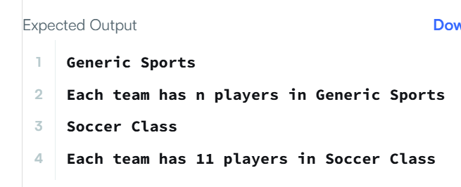

TASK 8.2: JAVA METHOD OVERRIDING 2 (SUPER KEYWORD)
PROGRAM:
import java.io.*;
import java.util.*;
class BiCycle{
String define_me(){
return "a vehicle with pedals.";
}
}
class MotorCycle extends BiCycle{
String define_me(){
return "a cycle with an engine.";
}
MotorCycle(){
System.out.println("Hello I am a motorcycle, I am " + define_me());
String temp = super.define_me();
System.out.println("My ancestor is a cycle who is " + temp);
}
}
public class Solution{
public static void main(String[] args){
MotorCycle M = new MotorCycle();
}
}

OUTPUT:
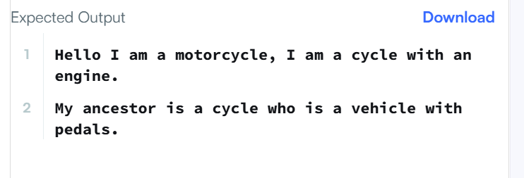

TASK 8.3: JAVA SINGLETONE PATTERN
PROGRAM:

TASK 8.4:

TASK 8 .5 : JAVA ITERATOR
PROGRAM:
import java.util.*;
public class Solution {
static void func(ArrayList mylist) {
Iterator it = mylist.iterator();
while (it.hasNext()) {
Object element = it.next();
if (element instanceof String) {
break;
}
}
while (it.hasNext()) {
Object element = it.next();
System.out.println((String) element);
}
}
public static void main(String[] args) {
ArrayList mylist = new ArrayList();
Scanner sc = new Scanner(System.in);
int n = sc.nextInt();
for (int i = 0; i < n; i++) {
mylist.add(sc.nextInt());
}
mylist.add("###");
int m = sc.nextInt();
for (int i = 0; i < m; i++) {
mylist.add(sc.next());
}

func(mylist);
}
}
OUTPUT:
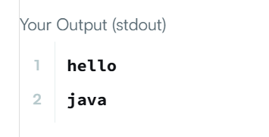

TASK 8.6: JAVA INTERFACE
PROGRAM:
import java.io.*;
import java.util.*;
interface AdvancedArithmetic {
int divisor_sum(int n);
}
class MyCalculator implements AdvancedArithmetic {
public int divisor_sum(int n) {
int sum = 0;
for (int i = 1; i <= n; i++) {
if (n % i == 0) {
sum += i;
}
}
return sum;
}
}
public class Solution {
public static void main(String[] args) {
MyCalculator myCalculator = new MyCalculator();
System.out.println("I implemented: " + myCalculator.getClass().getInterfaces()[0].getSimpleName());
Scanner sc = new Scanner(System.in);
int n = sc.nextInt();
System.out.println(myCalculator.divisor_sum(n));
sc.close();
}
}

OUTPUT:
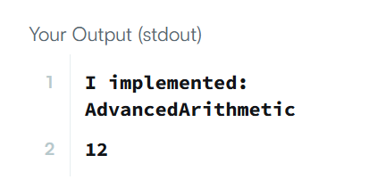

TASK 8.7:

TASK 8.8 : JAVA FACTORY
PROGRAM:
import java.util.*;
import java.security.*;
interface Food {
public String getType();
}
class Pizza implements Food {
public String getType() {
return "Someone ordered Fast Food!";
}
}
class Cake implements Food {
public String getType() {
return "Someone ordered a Dessert!";
}
}
class FoodFactory {
public Food getFood(String order) {
if (order.equals("pizza")) {
return new Pizza();
} else {
return new Cake();
}
}
}
public class Main {
public static void main(String[] args) {
Scanner sc = new Scanner(System.in);
FoodFactory foodFactory = new FoodFactory();
Food food = foodFactory.getFood(sc.nextLine());
System.out.println("The factory returned " + food.getClass());
System.out.println(food.getType());
}
}
OUTPUT:
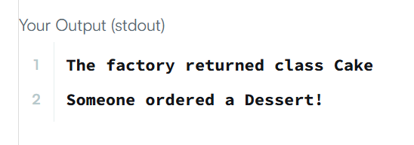

TASK 8.9: JAVA EXCEPTIONAL HANDLING
PROGRAM:
import java.io.*;
import java.util.*;
class MyCalculator {
public long power(int n, int p) throws Exception {
if (n < 0 || p < 0) {
throw new Exception("n or p should not be negative.");
}
if (n == 0 && p == 0) {
throw new Exception("n and p should not be zero.");
}
return (long) Math.pow(n, p);
}
}
public class Solution {
public static void main(String[] args) {
Scanner in = new Scanner(System.in);
MyCalculator myCalculator = new MyCalculator();
while (in.hasNextInt()) {
int n = in.nextInt();
int p = in.nextInt();
try {
System.out.println(myCalculator.power(n, p));
} catch (Exception e) {
System.out.println(e);
}
}
in.close();
}
}
OUTPUT:
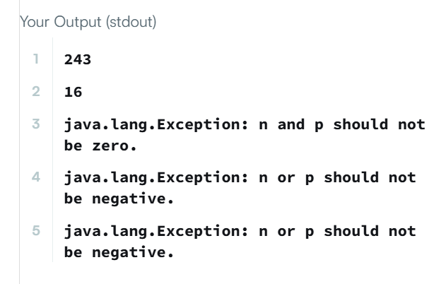

TASK 8.10: JAVA EXCEPTIONAL HANDLING (Try – catch)
PROGRAM:
import java.io.*;
import java.util.*;
public class Solution {
public static void main(String[] args) {
Scanner sc = new Scanner(System.in);
try {
int a = sc.nextInt();
int b = sc.nextInt();
System.out.println(a / b);
} catch (InputMismatchException e) {
System.out.println("java.util.InputMismatchException");
} catch (ArithmeticException e) {
System.out.println(e);
}
sc.close();
}
}
OUTPUT:
